Ayesha Zubair
52916
Compiler Construction Lab
Lab 3

Task 1:
Tokenize: We love compiler
Code:
#include<iostream>
using namespace std;
int main()
{
string input;
cout<<"Enter a sentence: ";
getline(cin,input);

string token="";

for(int i=0;i<input.length();i++)
{
if(input[i] != ' ')
token+=input[i];

else
{
cout<<"Token: "<<token<<endl;
token="";

}

}

}
Output:
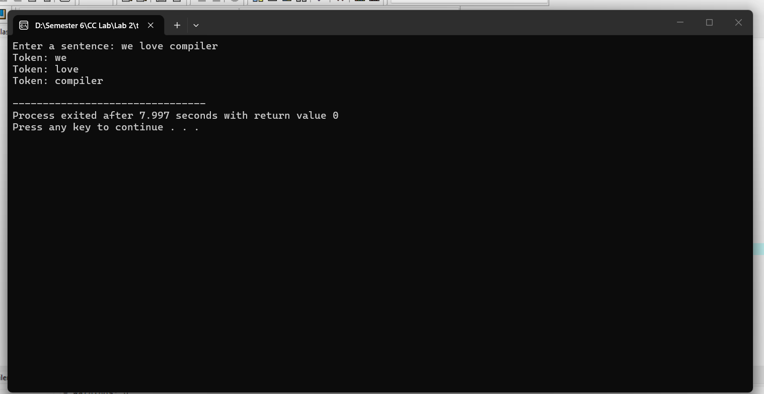

Task 2:
Tokenize and classify: int total= sum + 10;
Code:
#include<iostream>
using namespace std;
int main()
{
string input;
cout<<"Enter a sentence:";
getline(cin,input);
string token="";
for(int i=0;i<input.length();i++)
{
if(input[i] != ' ')
token+=input[i];

else
{
if(token=="int"||token=="float")
cout<<token<<" : Keyword\n";

else if(token[0]>='0' && token[0]<='9')
cout<<token<<" : Number\n";

else if(token=="+"||token=="=")
cout<<token<<" : Operator\n";

else if(token==";")
cout<<token<<" : Terminator\n";

else
cout<<token<<" : Identifier\n";

token="";

}
}

}
Output:
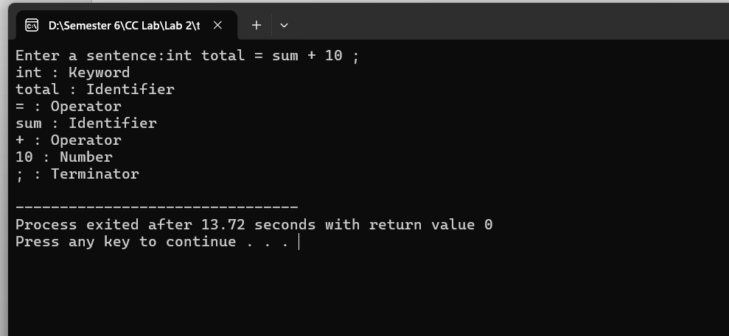

Task 3:
Extend program to recognize if, while,for
Code:
#include<iostream>
using namespace std;
int main()
{
string input;
cout<<"Enter a sentence:";
getline(cin,input);
string token="";
for(int i=0;i<input.length();i++)
{
if(input[i] != ' ')
token+=input[i];

else
{
if(token=="int"||token=="float")
cout<<token<<" : Keyword\n";

else if(token[0]>='0' && token[0]<='9')
cout<<token<<" : Number\n";

else if(token=="+"||token=="=")
cout<<token<<" : Operator\n";

else if(token=="for"||token=="while")
cout<<token<<" : Loop\n";

else if(token=="if")
cout<<token<<" : Conditional\n";

else
cout<<token<<" : Identifier\n";

token="";

}
}

}
Output:
